STITCH/DAYS FOR GIRLS
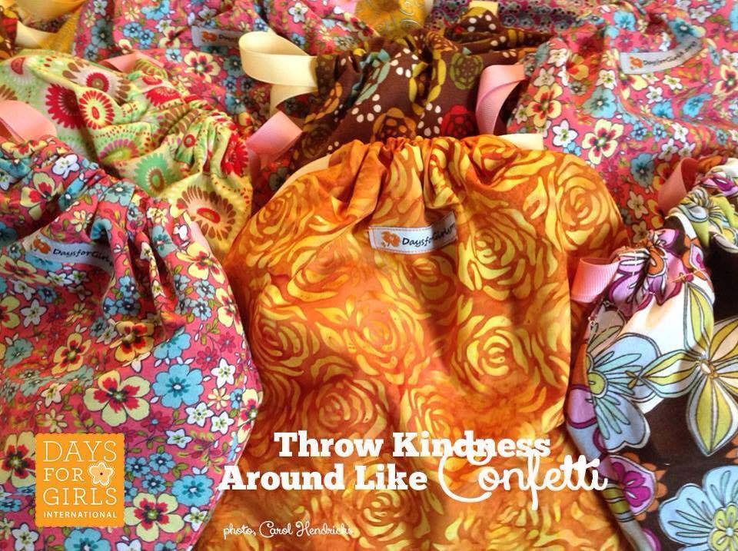
STITCH is a community of local (mostly) women working together to help women in other communities. We meet once a month, (generally on the last Saturday of the month at St Andrew’ s Annexe from 10 - 12, but both are variable), to support the Days For Girls charity - making washable sanitary products to enable disadvantaged girls to attend school ALL month and take full advantage of education.
All volunteers are welcome; there is cutting and planning and coffee and tea making as well as sewing. Donations of new 100% cotton (or brushed cotton) fabric are much appreciated (pretty, dark colours, no people or animals). We have a Facebook page (stitch) where we advertise our sessions, or contact us on staines-upon-thamesms@daysforgirls.org, text Benta Hickley on 07986239269, or phone Alison Maitland on 01784 482770 for more info.

